**HTML and CSS Notes**

* CSS tag specifiers should not have the same attributes. Instead, remove those attributes and put in a new combined specifier.

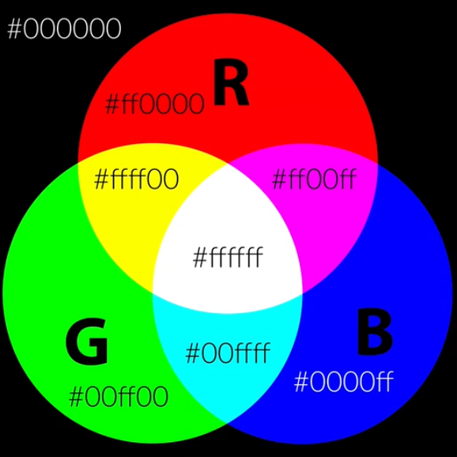

* By Default, when we specify the height and width of an element, margin, border and padding sizes are added to the height and width. In order to set the height of the element to contain them all, including that of the element, we use **box-sizing: border-box**.
* To maintain the aspect ratio of an image, we set width to **auto**.

**Typography Rules**

1. Use a font size between 15 and 25 pixels for body text.
2. Headlines and titles should generally be big. Sometimes, when using big headlines, it is advisable to decrease the font weight of the text.
3. Use line spacing between 120 and 150% of the font size.
4. 45 to 90 characters per line is the optimal line length that is easy to read.
5. Fonts to use include:
   1. Sans-serif
   2. Open Sans
   3. Lato
   4. Raleway
   5. Monsterrat
   6. PT Sans
   7. Cardo
   8. Merriweather
   9. PT Serif

**Choosing colours**

1. Use only one base colour (meaning only one colour that is not black, white or some shade of grey). Check out flatUI colours for base colours (also check out Bright’s colour site).

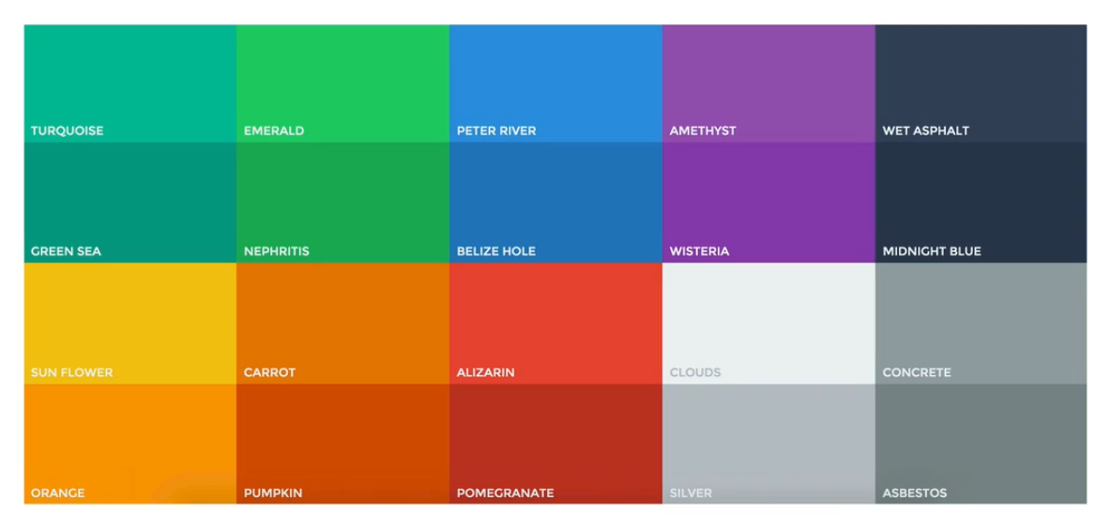

Figure 1. Any of these colours can't go wrong

If using multiple colours, use different shades of the single base colour. [0to255](http://www.0to255.com) is a good tool for getting these shades.

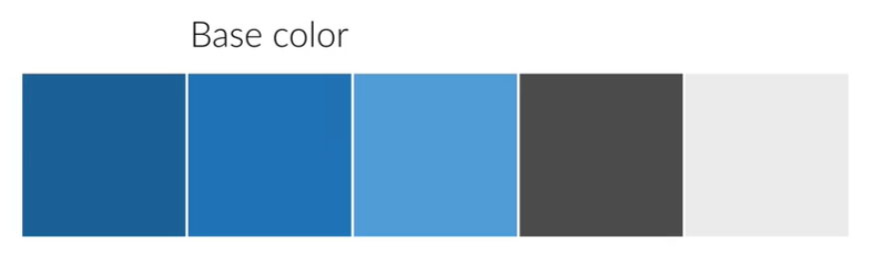

1. Use colours to draw attention or signify any element of importance on the site. For example, using bright colours for buttons.
2. Never use black in your design.
3. Choose colour wisely.

**Spacing and Layout**

1. Use whitespace:
   1. Put whitespace between your elements
   2. Put whitespace between your groups of elements
   3. Put whitespace between your website’s sections
   4. But do not exaggerate (they might lose relationship between one another).
2. Define Hierarchy
   1. Define where you want your audience to look first.
   2. Establish a flow that corresponds to your content’s message.
   3. Use whitespace to build that flow.

**User Experience**

It is achieved when the user’s goals and your business goals intertwin.

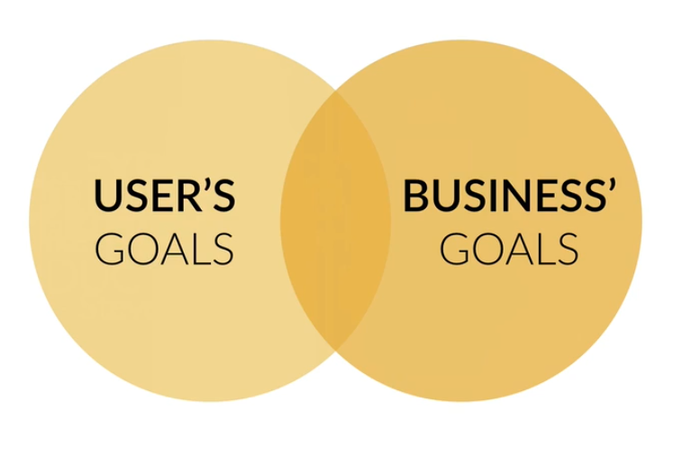

**Steps in building a fully functional website**

1. Define your project:
   1. Define goal of the project.
   2. Define your audience.
   3. Design with your goal and audience in mind.
2. Plan out everything:
   1. Plan your content: text, images, videos, icons, etc.
   2. Start thinking about visual hierarchy (defining the content before actually starting the design – content-first approach).
   3. Define the navigation.
   4. Define the site structure if it’s a bigger project.
3. Sketch ideas before designing
   1. Make as many sketches as you want, but don’t make it perfect.
   2. Never start designing without having an idea of what you want to build.
4. Design and develop your website
5. Optimization:
   1. Optimize performance: site speed
   2. Search engine Optimisation (SEO)
6. Launch the Masterpiece
7. Site Maintenance

**Three ingredients to responsive web design**

1. **Fluid grid**: all layout elements are sized in relative unites, such as percentages, instead of absolute units like pixels.
2. **Flexible images**: are also sized in relative unites.
3. **Media queries**: allow us to specify different CSS style rules for different browser widths.

**Front-end tips**

1. A block-level element always starts on a new line and takes up the full width available (stretches out to the left and right as far as it can).
2. An inline element does not start on a new line and only takes up as much width as necessary.
3. An Inline-block element, when compared with inline, it allows to set a width and height on the element, and the top and bottom margins/paddings are respected.

Compared to block, inline-block does not add a line-break after the element, so the element can sit next to other elements.

1. **text-align** doesn’t only work for text, it works for all inline or inline-block elements.